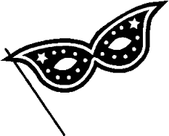
Character Mask
Book Project

Materials:
- Character mask organizer (see attached)
- Art supplies (paper plate, construction paper, markers, glue, yarn, or other materials)

Use the Character Mask organizer page to help you brainstorm and plan your character. Use your art supplies to create a mask that looks like the character in your book. You will hold your mask over your face to share information about your character in a small group. When presenting, you will share the information that you brainstormed on the organizer page. Be creative and have fun! Bonus: Dress as your character on the day the project is due.

Please return the bottom portion of this page to your teacher.
Student’s Name: ______________________________
Book Project Due Date: Friday, October 30. 2015
Name of Book ___________________________________________
Parent Signature ___________________________________________

Character Mask Organizer
Information about your book:
Title of Book: ___________________________________________
Author:_____________________________________ Fiction or Non-fiction: ___________________________________________
Information about your character
Character’s Name: ___________________________________________Something you liked about this character: _________________________________________________________________________________________________________________________________
Something important the character did: _________________________________________________________________________________________________________________________________
What this character looked like: ___________________________________________ ______________________________________________________________________________________How did you feel about this character? Did you like him/her? Why or why not? (give specific examples from the book):
____________________________________________________________________________________________________________________________________________________________________________

